

|  |  |  |
| --- | --- | --- |
| Document Name | Internal Communication | |
| **Applicable ISO:** | ISO 9001 | |
| Clause of the Standard | 7.4, 7.3 | |
| Code | S-HIMEX-G-AMD-0003 | |
| **Revision** | 02  08/22/2022 |  |
| Date |  |
| Department | AMD | |
| Area | Human Resources | |

Revision

00

Date

22/05/18

Description

FIRST EMITION

01

22/07/20

Updated information

"

Elaborated

ERIK

ECHEVERRIA

Raul Bugarin

02 08/22/2022 Updated area names and added section 7.6.

Raul Bugarin

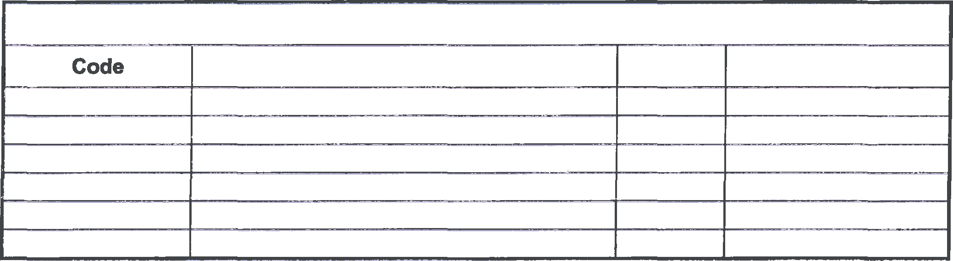

CONTROL OF RECORDS

Name

Time

**File**

|  |  |  |  |  |
| --- | --- | --- | --- | --- |
| Elaborated: | Raul Bugarin | **Authorize:** |  | Karla Jacques / Jeremy Zhang / Marco Esponda |
| **Position:** | Coordinator | **Position:** |  | HR Manager / AMD Director / Vice-President |
| **Signature** | | **Signature** |  |

|  |  |  |
| --- | --- | --- |
|  |  | HISENSE ELECTRONICA MEXICO S.A de C.V |
| lnternal Communication S-HIMEX-G-AMD-0003 |
| HUMAN RESOURCES R02 | |
| 1. OBJECTIVE   Establish an effective communication in HIMEX through the tools that the company provides.   1. SCOPE   All HIMEX personnel.   1. POLICIES N/A 2. **RESPONSABILITY AND AUTHORITY**    * AII departments have the responsibility to publish information from each department on the areas   assigned for it.   * + The department of Human Resources is responsibility of reviewing the general information and work environment publications before publishing, and has the authority to publish, return or cancel the information to the applicant department.   + Each department has the responsíbility to publish technical information or procedures in the assign ' spaces (blackboards), in case of needing to publish technical information in communication screen» (Hisense TV), they will have to send the information to the administration department for its revision to the Assistant Administrative and approved by the Manager and the Director of Administration  1. **DEFINITIONS**   HIMEX: Hisense Electrónica México SA de CV AMD: Administration   1. REFERENCES   N/A   1. DEVELOPMENT   AII internal policies should:   * + Include Hisense logo | | |



Page 1 of 6

|  |  |  |
| --- | --- | --- |
|  |  | HISENSE ELECTRONICA MEXICO S.A de C.V |
| Internal Communication S-HIMEX-G-AMD-0003 |
| HUMAN RESOURCES R02 | |
| * Hisense corporate colors * Legible font (Arial, Calibri, Arial black, etc.) * Font size 12 * If pictures are required we encourage you to use our official mascot Harley * Power point must be elaborate in HISENSE TV TEMPLATE.   1. All departments can publish information of Hisense Corporation or department information (new projects).   The ways they can publish it are:   * + - Hisense TV (Canteen Screens)     - Hisense Boards     - Hisense Facebook (Social Media) or App.   1. The department that wants to publish information needs to create the presentation or template information (check policies). | | |



* 1. After finishing the publication (advertising) the applicant department needs to submit the information to the Human Resources department to be reviewed by the administrative assistant or coordinator, who will check the next points:
     1. Published information can not include offensive information.
     2. All information from HIMEX is private, any information on social media must be careful not to show private information.
     3. Do not publish Information than will affect the integrity of the employees.
  2. If the information to be published is in accordance with HIMEX ethics, the Human Resources department approves the publication on boards and Hisense TV on canteens.
  3. Hisense TV & Boards

7.5.1. The publication period is for 1 day to 30 days (TV), if some information needs to remain published for more time, the applicant department needs to report it to the Human Resources Department.

Paee 2 of 6

|  |  |  |
| --- | --- | --- |
|  |  | HISENSE ELECTRONICA MEXICO S.A de C.V |
| Internal Communication S-HIMEX-G-AMD-0003 |
| HUMAN RESOURCES R02 | |
| * + 1. For technical information or process, each department will have assigned boards, each publican. needs to be reviewed and authorized by the manager of each department.     2. For technical information to be published on screens (Hisense TV), the applicant department should send the information in the authorized template, define the publication time and the purpose of the publication and request the authorization to the Human Resources Department, once it has been approved, the Administrative Assistant of HR will publish the information in the next 24 hrs.   1. Hisense Facebook (Social Media) and App.      1. For social media or Hisense App publications you should send the information to the Human Resources department to be reviewed by the Administrative Assistant and authorized by the HR Manager.      2. Once the publication is authorized, it will be published in the following 24 hrs.      3. At the end of the publication period the applicant department can update information, they need to request the administration department to update the information on (TV, Signboards or social media).      4. All employees can access Facebook to get information about our events. o Employee needs access to Facebook Hisense         + Sent request for Friendship         + Employee can download photos we share and like our posts      5. For our Hisense App, employees have to download the app or use the web App version, each employee will be given a User name and password that they have to use to access the app. This | | |

information will be provided to them by Human Resources during the hiring process.

7.7. If after 30 days the department doesn’t request the update, the Administration department will remove the publication.

HISENSE ELECTRONICA MEXICO S.A de C.V

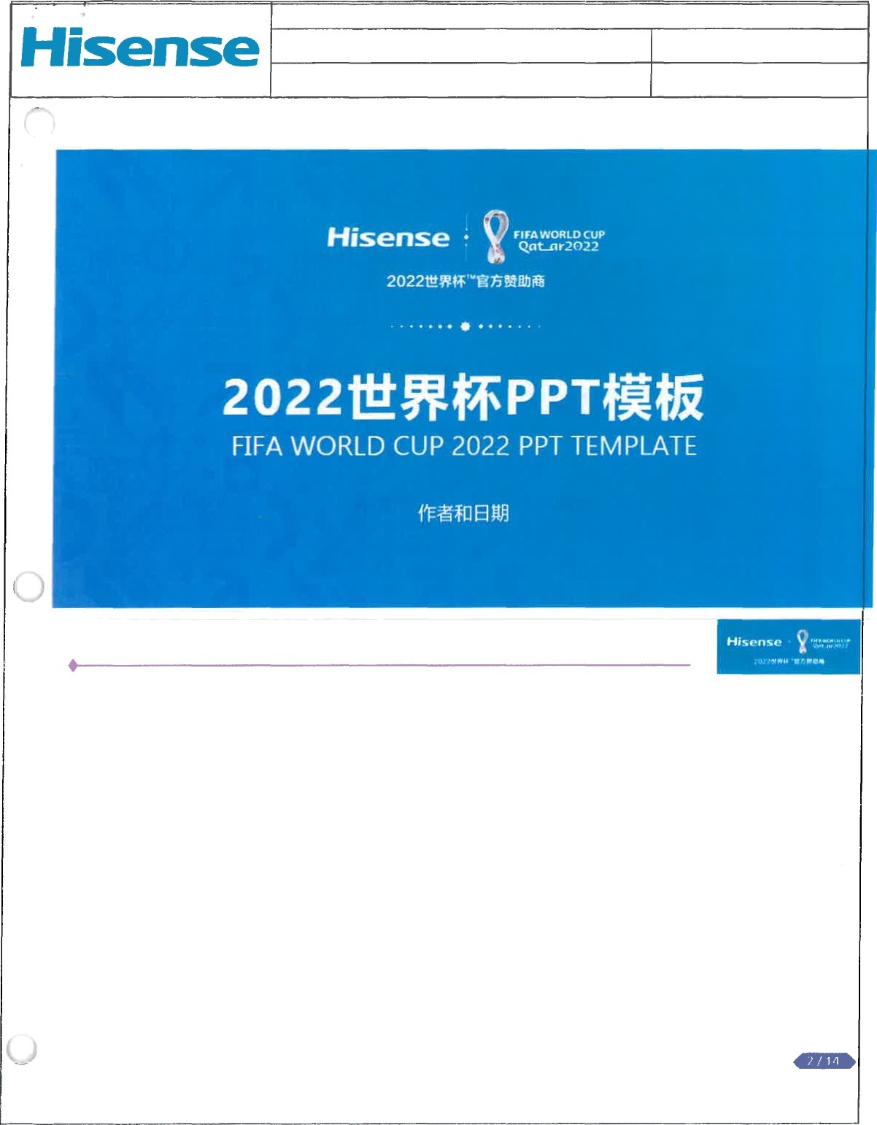

Internal Communication S-HIMEX-G-AMD-0003

# HUMAN RESOURCES R02

Hisense Template

Paee 4 of 6

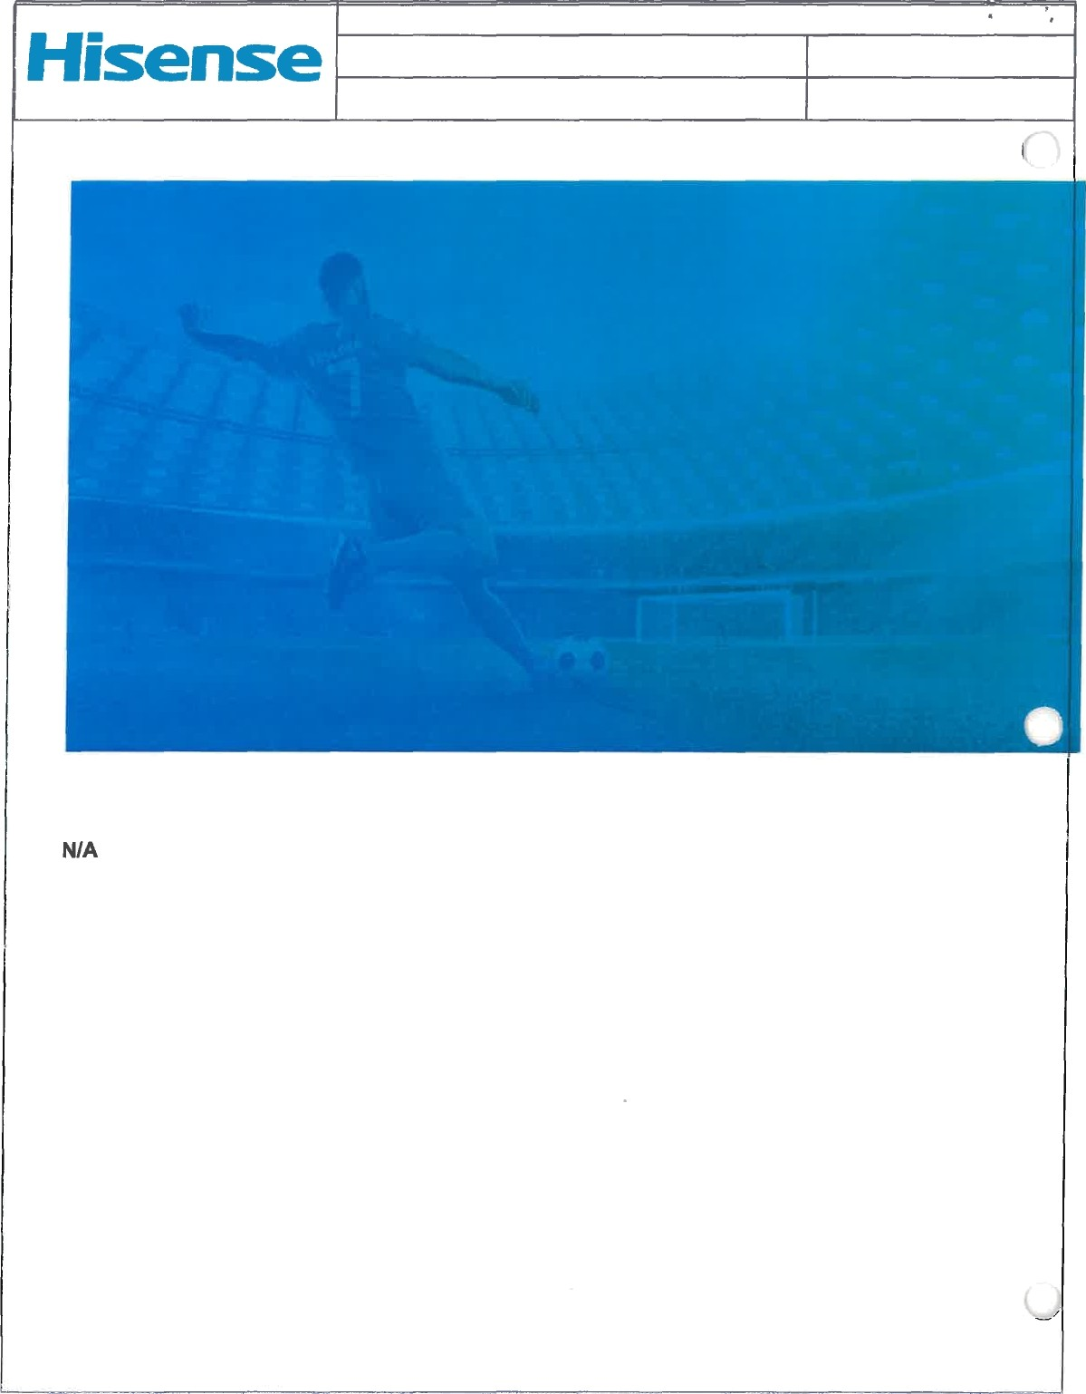HISENSE ELECTRONICA MEXICO S.A de C.V

# Internal Communication S-HIMEX-G-AMD-0003 HUMAN RESOURCES R02

8. FLOW CHART

Pa•e 5 of 6